**NPTEL ASSIGNMENT**

**LINUX OPERATING SYSTEM- INTERMEDIATE LEVEL**

1)GREP COMMAND

ASSIGNMENTS

1) Explore some other commands like -E, + and ?

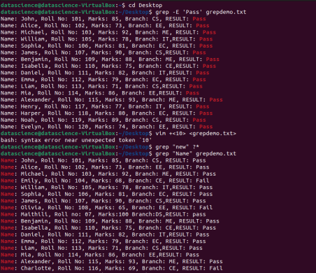

2) MORE ON GREP COMMAND

Assignment:

List those entries that are 5 letters long and starts with Y



3) THE SED COMMAND

Assignments:

1) Use the same text file seddemo.txt

2) Try to print records from 6th to 12th line.

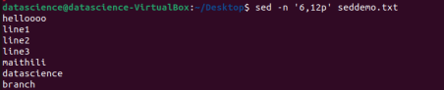

4)MORE ON SED COMMAND

Assignments :

1) Use the same text file seddemo.txt

2) Try to replace or substitute name Ankit with Ashish

